CSE/EEE 120
Simulation Lab 0 Answer Sheet
Simulator Tutorial: Using Logisim
Name:____Christopher McCoy______________________
Date:________________________
Task A: Creating a Subcircuit
Include a picture of your Logisim circuit SUB_TRY.circ here:
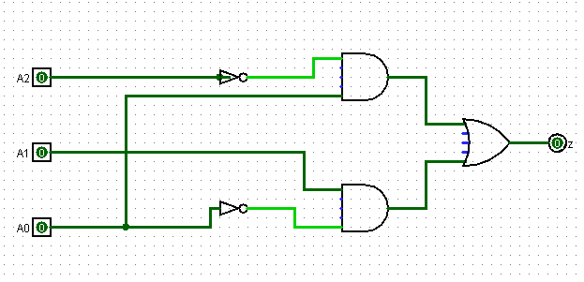
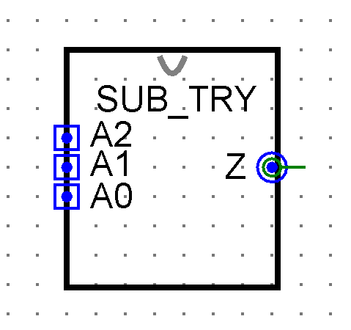

Include a picture of your Logisim circuit subdemo.circ here:
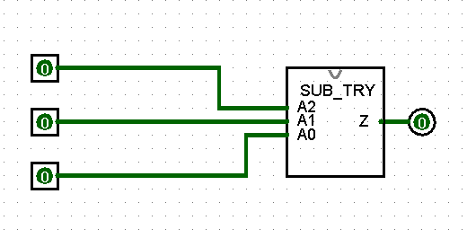

Create a truth table for the output function Z in Error: Reference source not found. Test your subcircuit and place your result in the Output column.
Input  (Logic Values) |  |  | Output  (Logic Values)
A2 | A1 | A0 | Z
T | T | T | F
T | T | F | T
T | F | T | F
T | F | F | F
F | T | T | T
F | T | F | T
F | F | T | T
F | F | F | F

Task B: 4-Bit Keyboard
Include a picture of your Logisim circuit implementation of the 4-Bit Keyboard circuit that you created under the name of kbddemo.circ here:
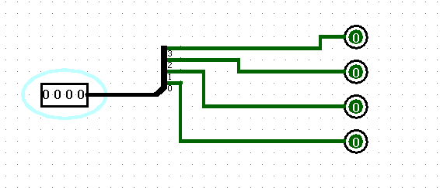

Task C: Hex Display
Include a picture of your Logisim circuit implementation of the Hexadecimal Display circuit that you created under the name of dispdemo.circ here:
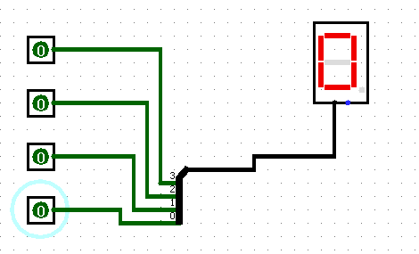
Task D: Tunnels
Include a picture of your Logisim circuit implementation of the circuit using Tunnels that you created under the name of tunneldemo.circ here:
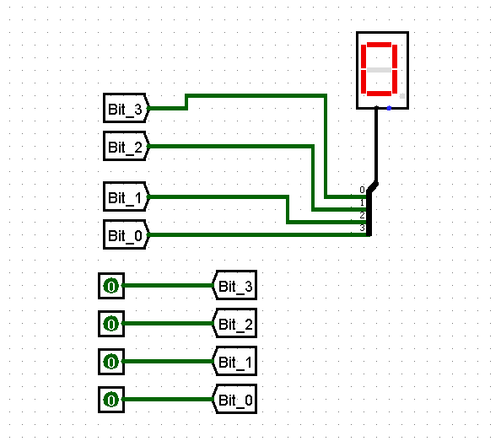

Simulation Lab 0: Lab Report Grade Sheet

Name:

Instructor Assessment
Grading Criteria | Max Points | Points Lost
Template
Neatness, Clarity, and Concision | 1
Description of Assigned Tasks, Work Performed & Outcomes Met
Task A: Creating a Subcircuit | 3
Task B: 4-Bit Keyboard | 2
Task C: Hex Display | 2
Task D: Tunnels | 2
 | Points Lost
Lab Score (10 points total) | Late Lab
 | Lab Score

